EXP NO : 1 Data preprocessing in a given data

AIM : To load a dataset using Pandas, check and handle missing values, select numerical features, and normalize the data using StandardScaler from the Scikit-learn library.

ALGORITHM :
- Start the program.
- Import the Pandas library and StandardScaler from Scikit-learn.
- Load the dataset from the file data.csv.
- Display the first five rows of the original dataset.
- Check and display the number of missing values in each column.
- Fill missing numerical values with the mean of their respective columns.
- Select the numerical columns Hours_Studied, Attendance, Assignments, and Marks.
- Create a StandardScaler object and normalize the selected data using fit_transform().
- Convert the normalized data into a Pandas DataFrame with the original column names.
- Display the first five rows of the normalized dataset.
- Stop the program.

PROGRAM :
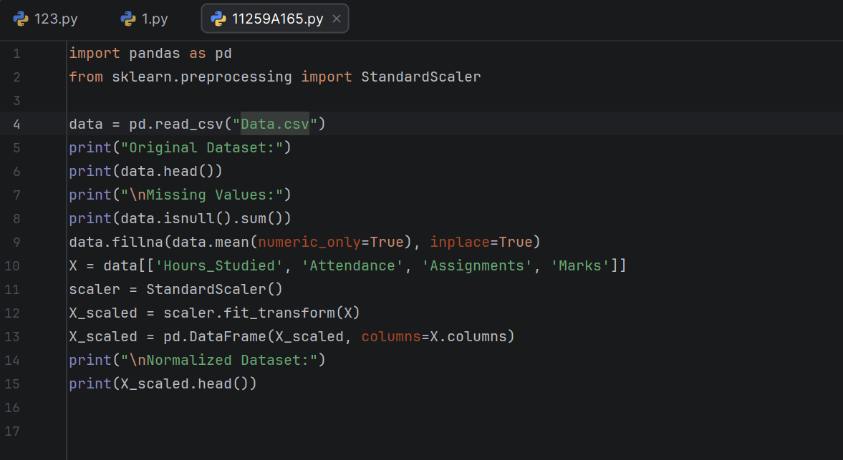

OUTPUT :

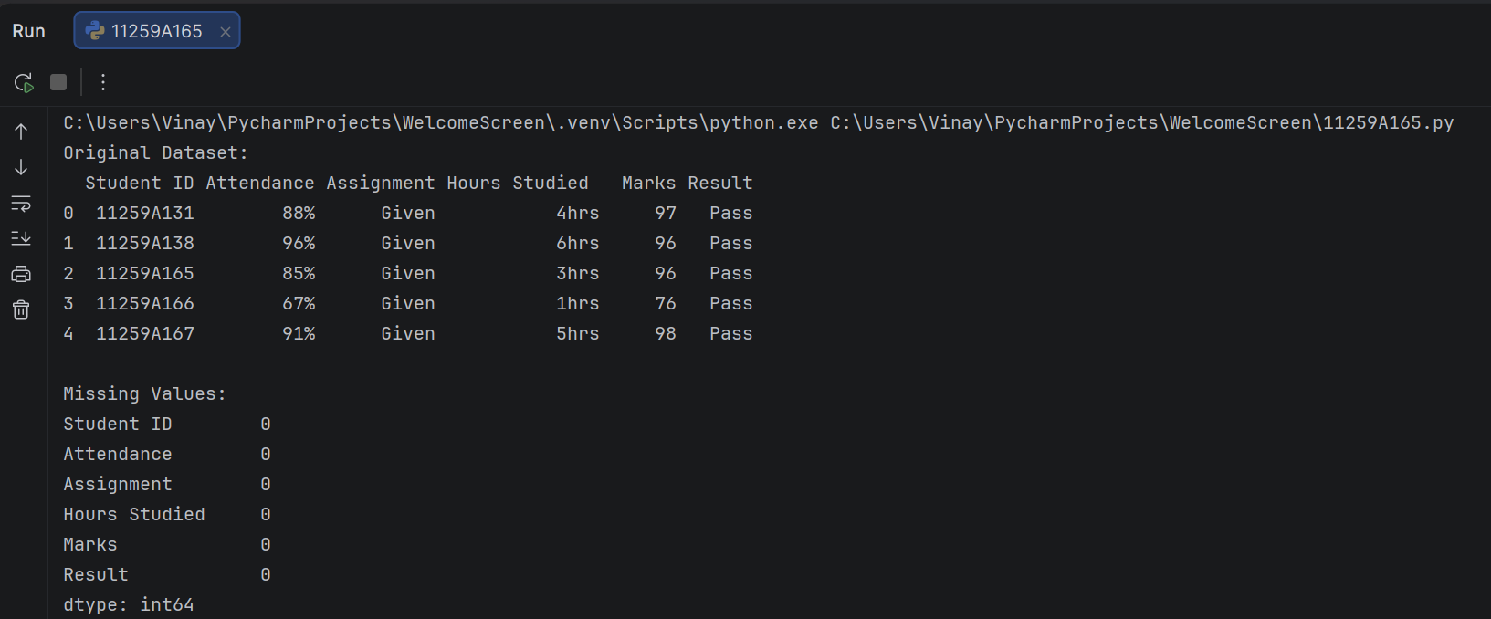

RESULT : Thus, the Python program was executed to load the dataset, identify and handle missing numerical values, and normalize the selected features using StandardScaler. The normalized dataset was displayed successfully, with the numerical features scaled to approximately zero mean and unit variance.

